Gate 5 — Advanced Playwright and Debugging Report

Gate 5 — Advanced Playwright and Debugging
Purpose of this document. A demo report that will cover all the flows regarding playwright debugging and diagnositcs
- Participant: Premchand Chellisseril Pramod Date: 04-07-2026 Branch: premchand-week05-gate5
- Assessment: Week 5 Gate 5 — Offline and resilient flow, Returns and refunds flow, Logging

1. Objective & user story
Automate sale queueing during offline network and synchronizing the sales properly once network is back on. →
Offline Flow: Offline → Queue sale → Reconnect → One post
Refund Flow: Full refund, Partial Refund, Rejected, No double pay

2. Configuration
Layer Pinned choice

Test directory ./tests
Trace on-first-retry
Screenshot only-on-failure
Video retain-on-failure

3. Framework design

3.1 Page Object Model
- Page classes — CartPage, ProductPage, HomePage, CheckoutPage, SearchPage, OrderPage. Each holds private By locators and intention-named methods

3.2 Fixtures
- diagnostic.fixture generates a unique correlationId for every test and creates a logger that records everything during the test and attaches the logs
- app.fixture collects evidences and attaches it to Playwright reports

3.3 Reporting
Playwright reports after run of every tests
4. Project structure
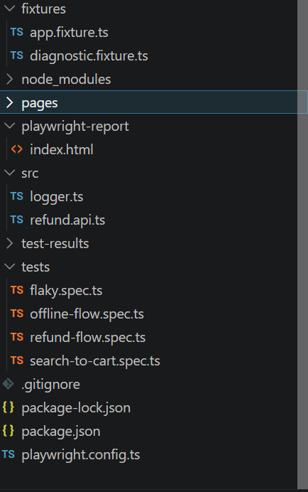

5. Scenarios covered
- Flaky test using timeouts: Try to run a test with improper locators or timeouts
- Offline and resilient flow: Drop the network mid-checkout, the banner shows, sales queue and on reconnect it syncs exactly once
- Returns and refunds: Full and partial refunds to the exact paise and an idempotent refund
- Search to checkout flow: Search and add product to cart and checkout to demonstrate logging

6. How to run
# Removing flakiness test
npx playwright test tests/flaky.spec.ts –repeat-each=10

#Offline path test
npx playwright test tests/offline-flow.spec.ts

#Refund and return path test
npx playwright test tests/refund-flow.spec.ts

#Search to checkout flow
npx playwright test tests/search-to-cart.spec.ts

7. Results
1. Removing flaky locator test
STATUS:PASSED
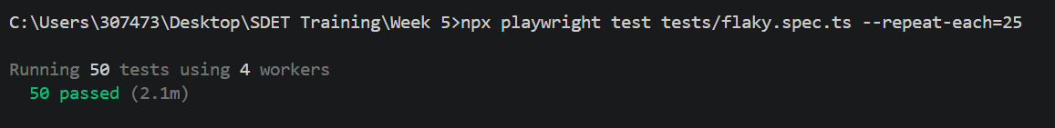

2. Offline and resilient flow test
STATUS: PASSED
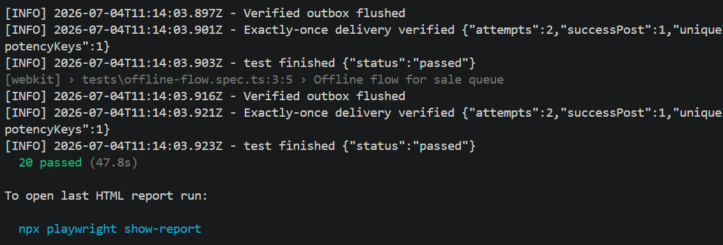

3. Refund and returns flow test
FULL REFUND STATUS: PASSED
PARTIAL REFUND STATUS: PASSED
REJECTING INVALID REFUND STATUS: PASSED
IDEMPOTENT REFUND STATUS: PASSED
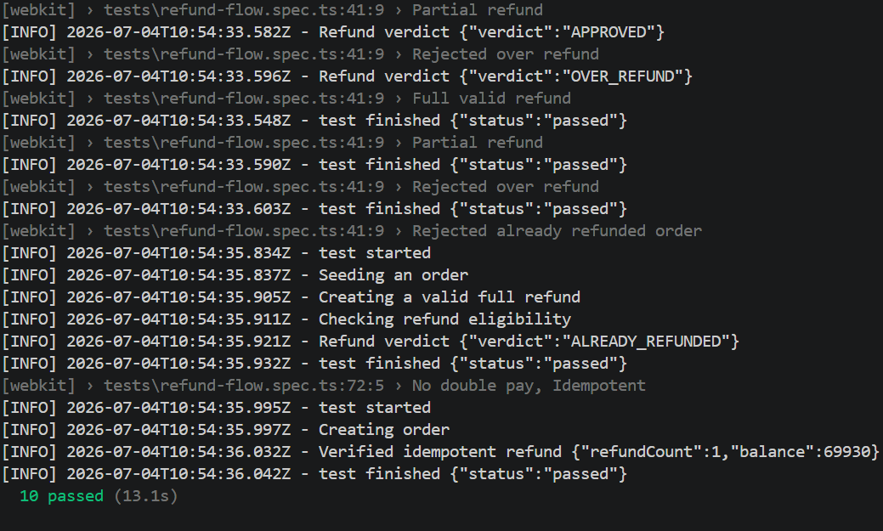

4.Product checkout flow to demonstrate logging
STATUS: PASSED
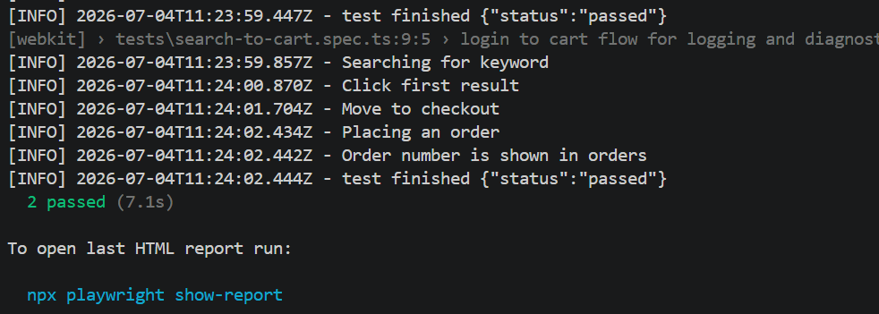

8. Evidence
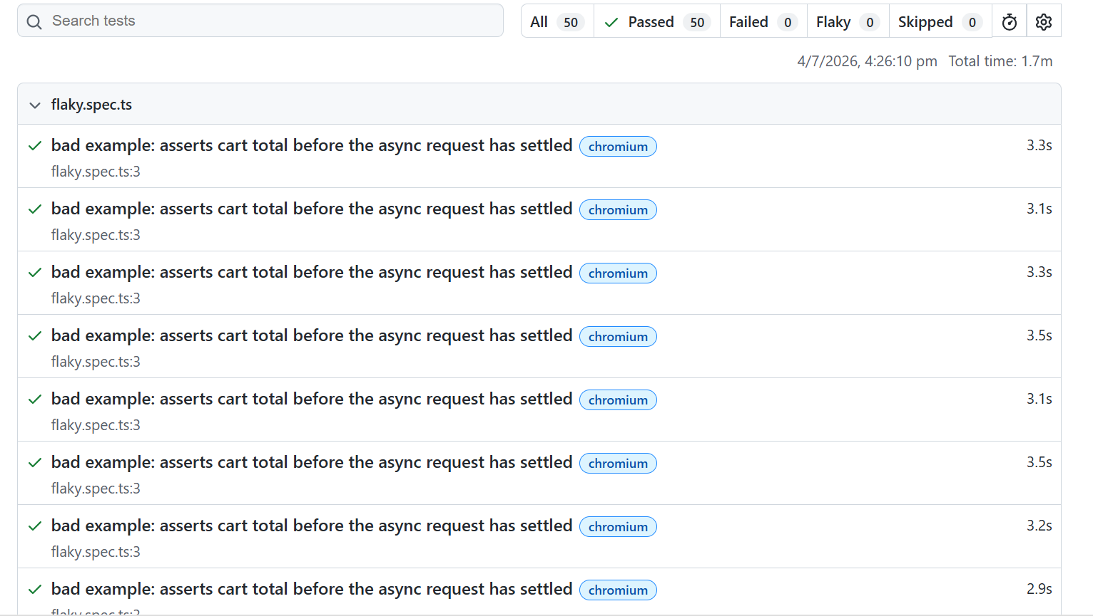
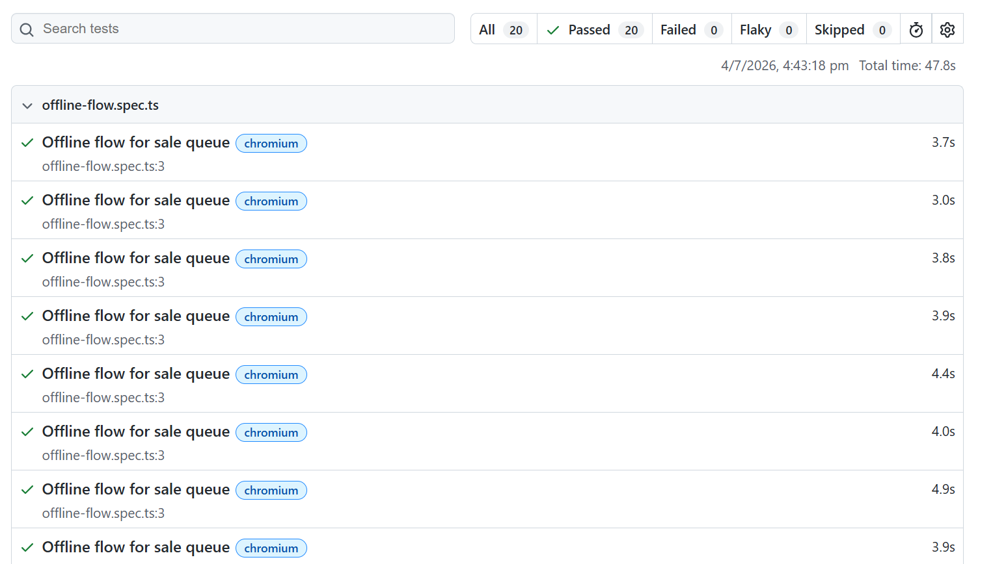

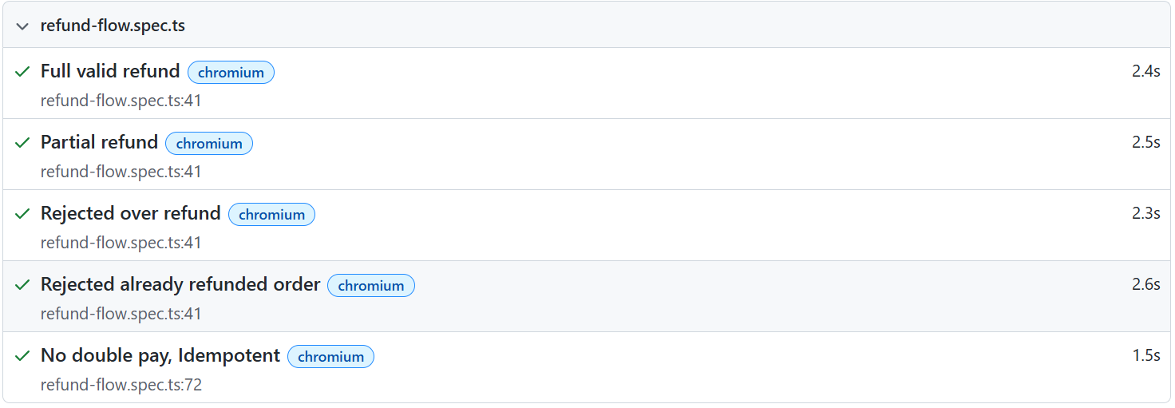
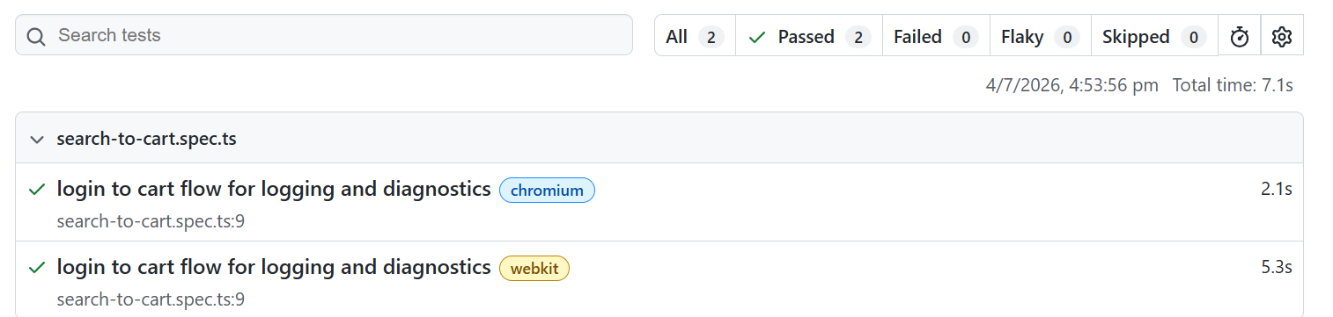

10. Issues & limitations
- Flakiness due to explicit timeout. Element could not be found
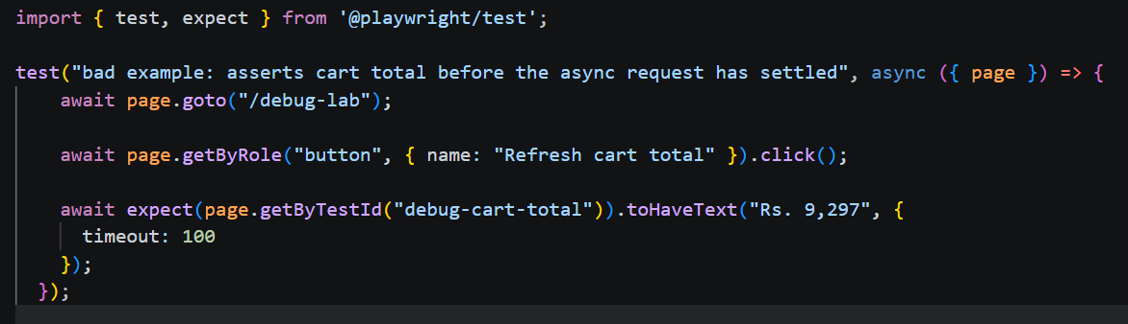
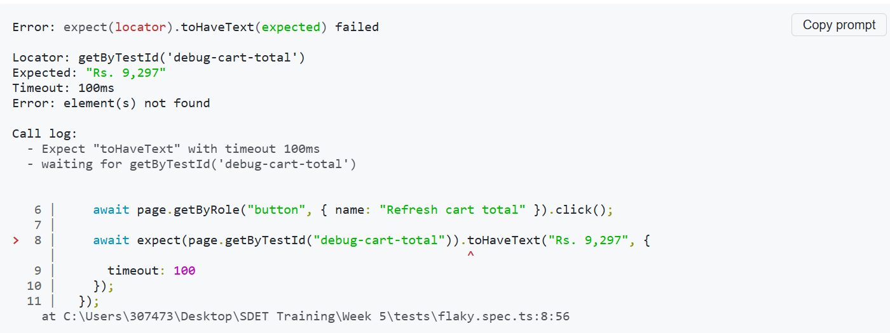
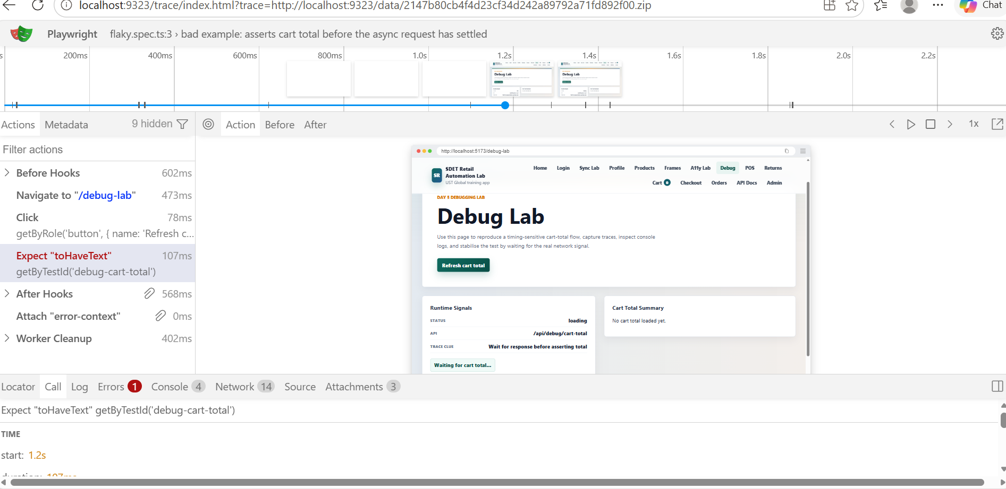
FIX: Remove unwanted timeouts and prefer auto-waits

- Page couldn’t load due to network turned off.
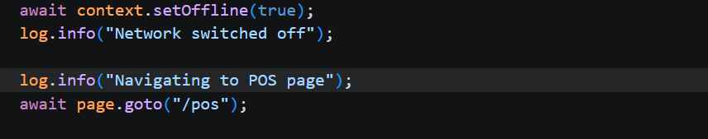
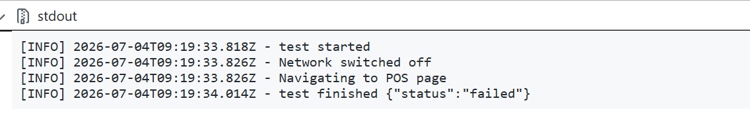
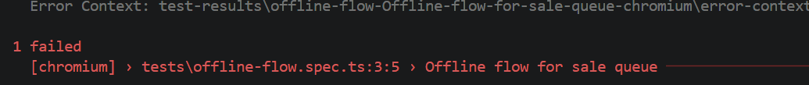
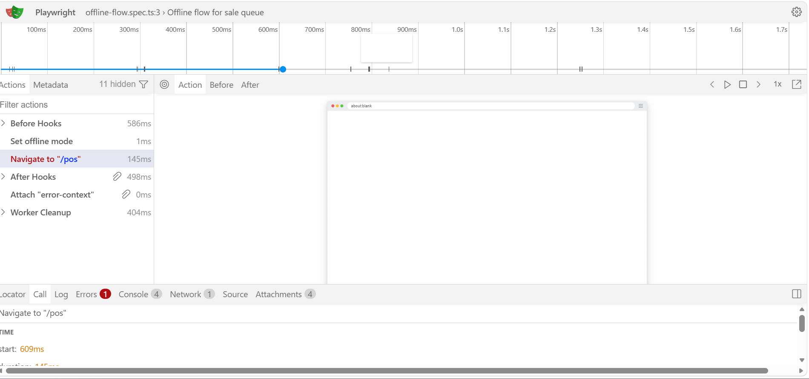
FIX: Load the page first, then turn off the network

- Double refund for duplicate request. Idempotency key was not passed with the request, resulting in duplicate refund request and second request was created as new request with 201 status code
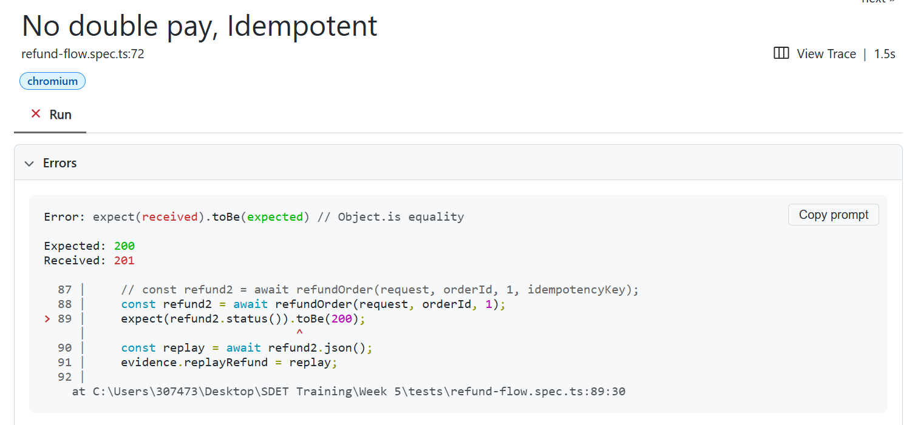
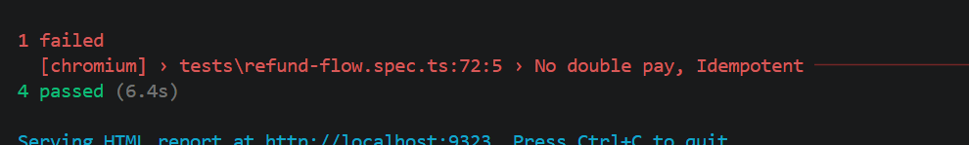
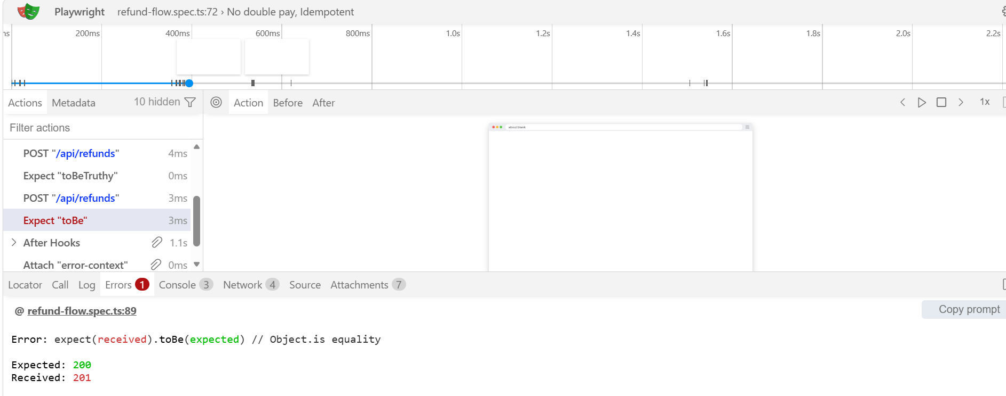
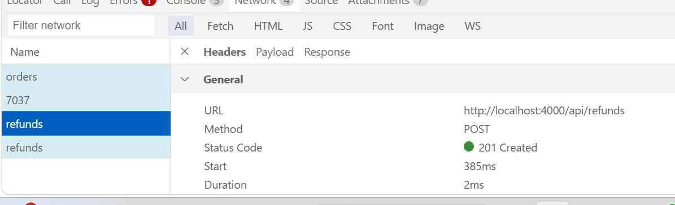
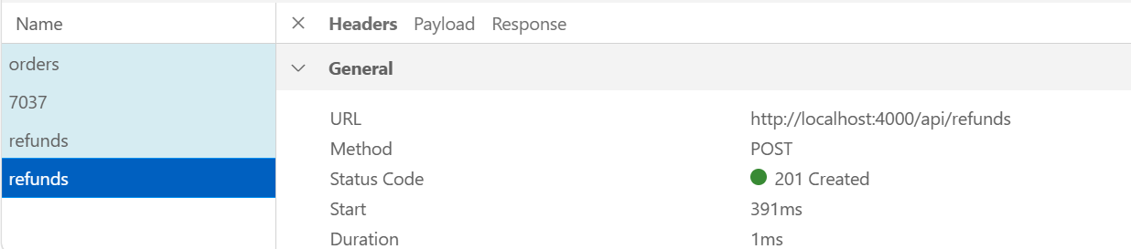
FIX: Add idempotency key with refund request. Duplicate request returns the same result with 200 status code

11. Conclusion
A maintainable Playwright project which includes diagnostics and logging for evidence of each test will help find any errors easier and document all steps. Returns and refunds are simulated properly considering all scenarios and ensures no duplicate requests are passed, by using idempotency keys.

